**Objective:** Make Subdirectory of your name in root directory.

**Explanation:** This command creates a new directory with the specified name in the G drive's root. We can use md or mkdir to create subdirectory.

**Syntax:**

**Output:**

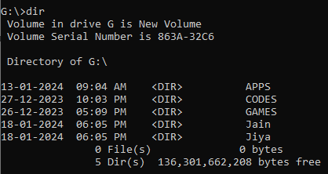

**Objective:** Display Date & Time on screen.

**Explanation:** This command can set or display the current system date and time on screen.

**Syntax of Date:**

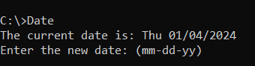**Output:**

**Syntax of Time:**



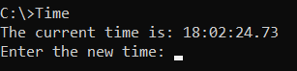**Output:**

**Objective:** Display the structure of root directory.

**Explanation:** Displays a tree-like structure of the root directory, including all subdirectories and files, sorted by name.

**Syntax:**

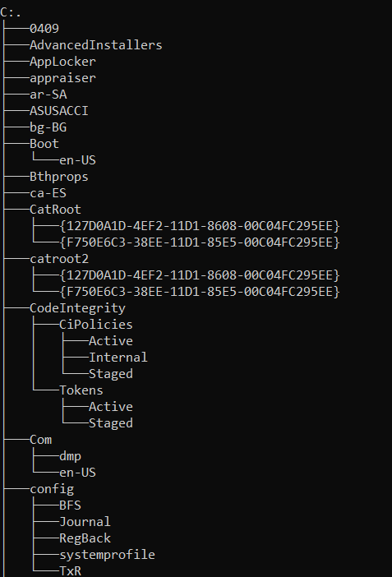**Output:**

**Objective:** Make file “ABC” in subdirectory “Sage”.

**Explanation:** Creates a new file named "ABC.txt" in the "Sage" subdirectory and allows to enter text.

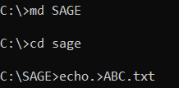**Syntax:**

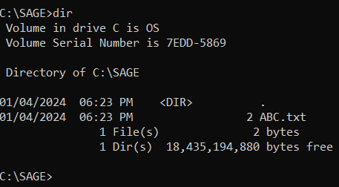**Output:**

**Objective:** Display the content of file “ABC”.

**Explanation:** This command will output the content of the "ABC.txt" file located in the "Sage" subdirectory on the C drive. If the file contains text, we'll see the text displayed in the command prompt.

**Syntax:**

**Output:**

**Objective:** Make subdirectory “MCA” in root directory.

**Explanation:** This command creates a new directory named "MCA" in the root directory of the C drive.

**Syntax:**

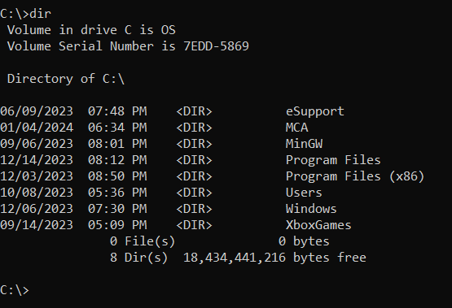**Output:**

**Objective:** Give new name to the file “ABC” as “XYZ”.

**Explanation:** This command renames the file from "ABC.txt" to "XYZ.txt" in the "Sage" subdirectory on the C drive.

**Syntax:**

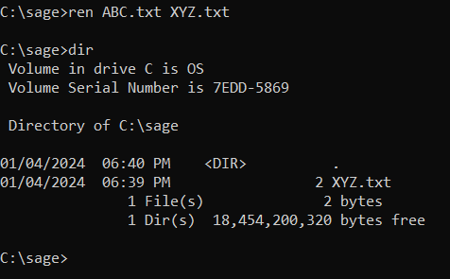**Output:**

**Objective:** Display the name of the disk.

**Explanation:** Displays the disk volume label and serial number. If don't specify a drive, it shows the volume label of the current drive.

**Syntax:**

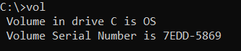**Output:**

**Objective:** Make Subdirectory “BCA” inside subdirectory “Sage”.

**Explanation:** Displays the disk volume label and serial number. If don't specify a drive, it shows the volume label of the current drive.

**Syntax:**

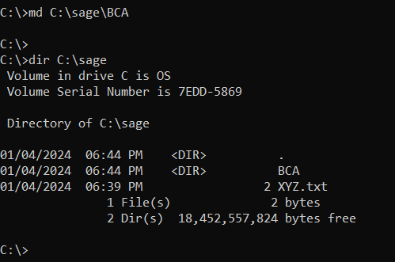**Output:**

**Objective:** Remove subdirectory “MCA”.

**Explanation:** The command removes the specified directory, but it will only work if the directory is empty.

**Syntax:**

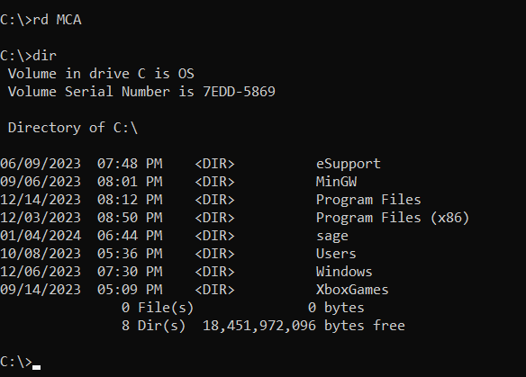**Output:**

**Objective:** Make an extra copy of file “XYZ” in subdirectory “BCA”.

**Explanation:** Copies a file from a source location to a destination location.

**Syntax:**



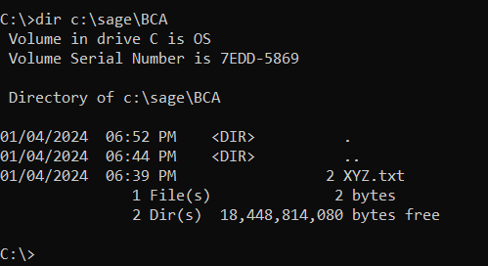**Output:**

**Objective:** Display those files on screen which are having secondary name as “.c”..

**Explanation:** Display copies of file from a source location to a destination location. Specifies the directory (C:) and the pattern to match files with a ".c" extension.

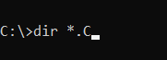**Syntax:**

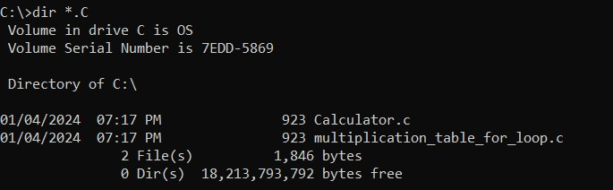**Output:**

**Objective:** Remove file “xyz” from subdirectory “BCA”.

**Explanation:** Deletes or remove the files.

**Syntax:**



**Output:**

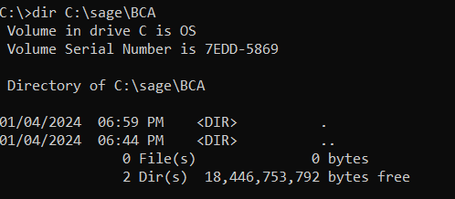

**Objective:** Change position of file “ABC” of subdirectory “sage” to root directory.

**Explanation:** Moves a file or directory from one location to another.

**Syntax:**

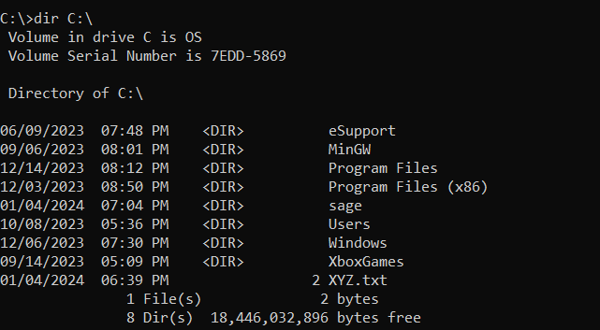**Output:**

**Objective:** Display those file which are having primary name of three characters and secondary name as anything.

**Explanation:** Lists files and directories in the specified directory that match the given pattern. The ??? wildcard represents any three characters in the primary name, and .* represents any secondary name (file extension).

**Syntax:**

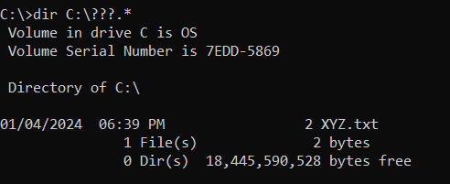**Output:**